Wo essen und trinken Sie? → Was sind Ihre Lieblingsorte? Was isst oder trinkt man dort?

→ Where do you eat and drink? What are your favorite places? What do you eat or drink there?

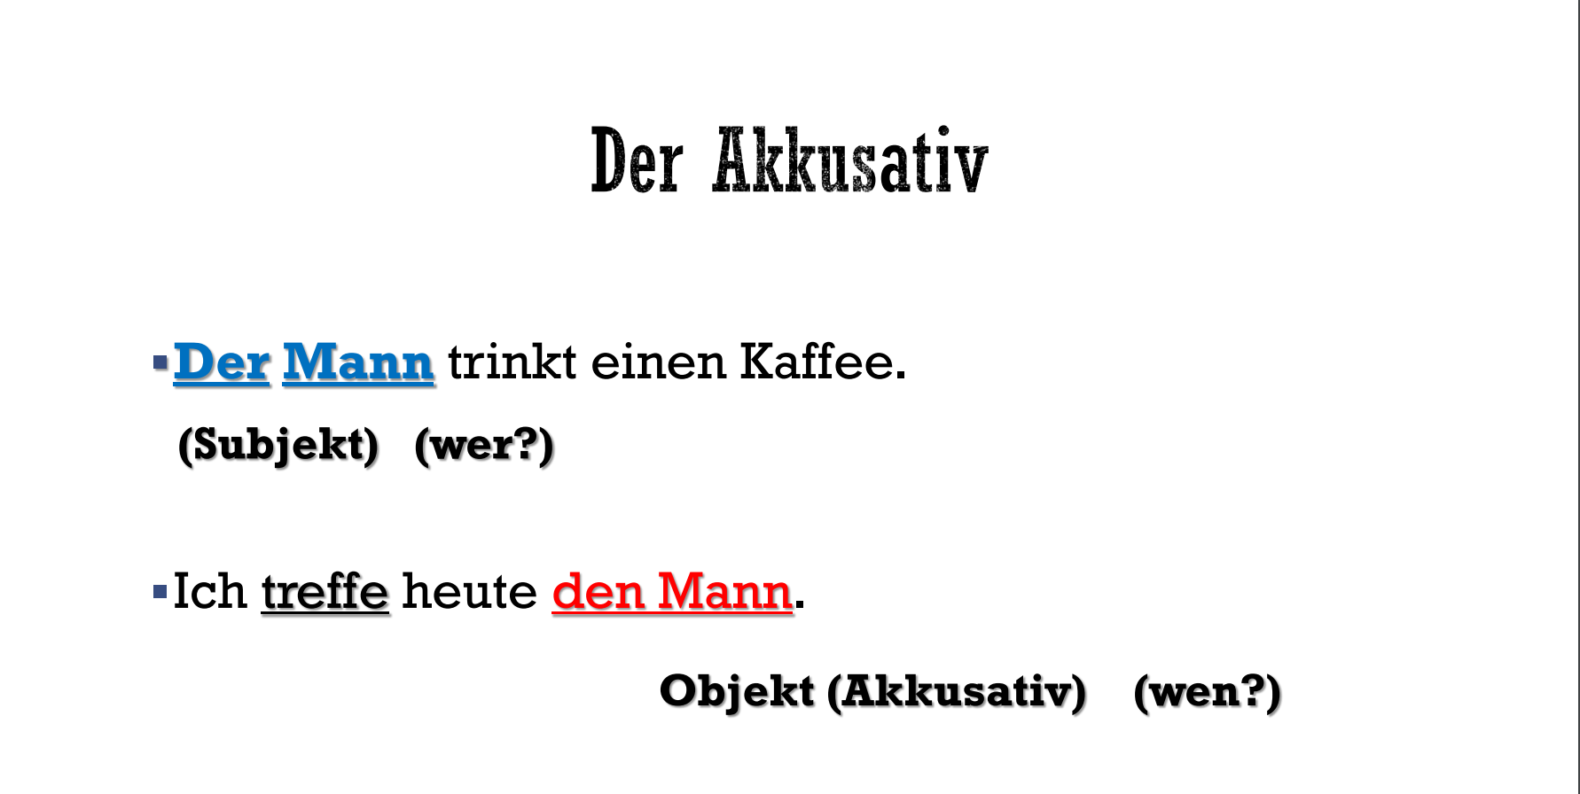

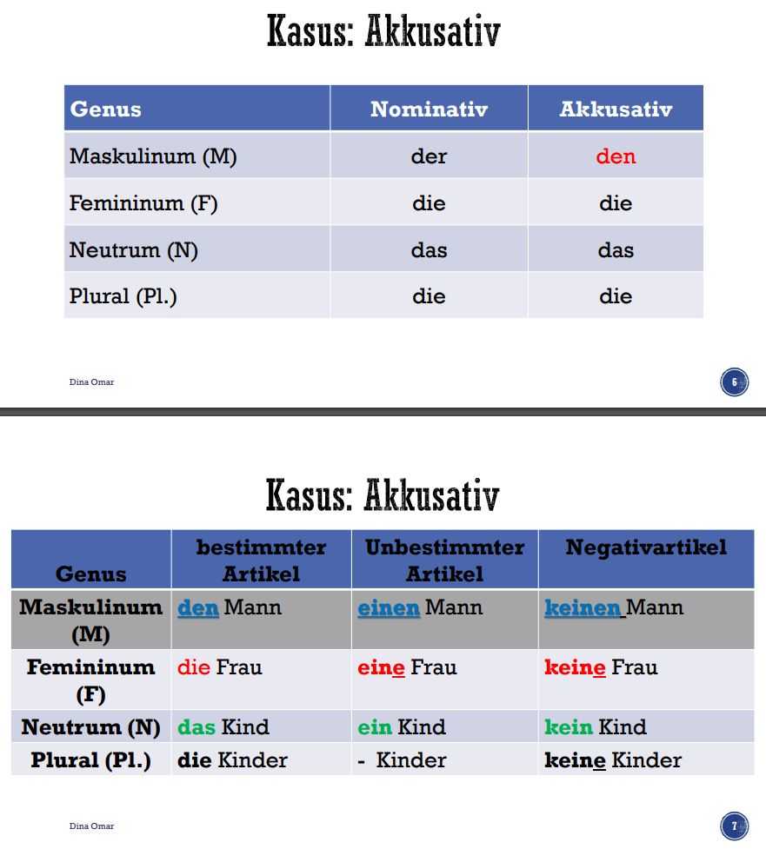

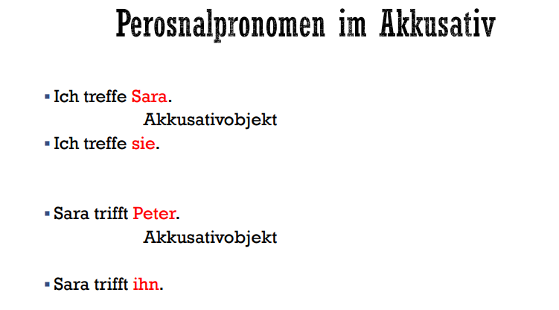

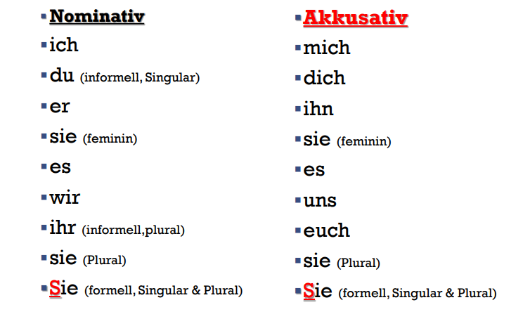

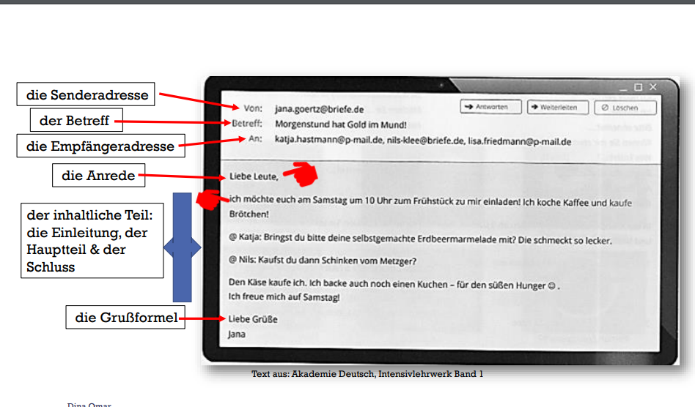

1. **Die Senderadresse (Sender's Address):**
   * This is the email address of the person who is sending the email.
   * Example: jana.goertz@briefe.de.
2. **Der Betreff (Subject):**
   * This is the subject line of the email, summarizing its purpose.
   * Example: Morgenstund hat Gold im Mund! (A German proverb meaning "The early bird catches the worm!").
3. **Die Empfängeradresse (Recipient's Address):**
   * These are the email addresses of the people who will receive the email.
   * Example: katja.hastmann@p-mail.de, nils-klee@briefe.de, etc.
4. **Die Anrede (Salutation):**
   * This is how you greet the recipients in the email.
   * Example: Liebe Leute, (Dear people,).
5. **Der inhaltliche Teil (Content Section):**
   * This is the main body of the email, consisting of:
     + **Einleitung (Introduction):** Briefly explain the purpose of the email.
     + **Hauptteil (Main Part):** Include the details of your message.
     + **Schluss (Conclusion):** End the email with any closing thoughts or reminders.
6. Example in the image:
   * **Einleitung:** "Ich möchte euch am Samstag um 10 Uhr zum Frühstück zu mir einladen!" (I’d like to invite you to breakfast at my place on Saturday at 10 a.m.!)
   * **Hauptteil:** Details about the invitation, e.g., asking someone to bring strawberry jam, someone else to get ham, etc.
   * **Schluss:** "Ich freue mich auf Samstag!" (I’m looking forward to Saturday!).
7. **Die Grußformel (Closing Formula):**
   * This is the closing line of the email, often polite and friendly.
   * Example: Liebe Grüße, (Kind regards,) followed by the sender’s name.

### **How to Write an Email Like This**

1. **Start with the Basics:**
   * Write your own email address in the "From" field.
   * Add the recipient's email address in the "To" field.
   * Create a subject line that captures the essence of your message.
2. **Write the Greeting (Anrede):**
   * Use a friendly or formal greeting depending on your relationship with the recipients.
   * Examples:
     + Informal: Hallo zusammen, (Hello everyone,)
     + Formal: Sehr geehrte Damen und Herren, (Dear Sir/Madam,)
3. **Structure Your Content (Inhaltlicher Teil):**
   * **Introduction:** Explain the purpose of the email briefly.
   * **Main Body:** Include all relevant details, such as dates, times, and requests.
   * **Conclusion:** Wrap up the email with a friendly note.
4. **Close the Email (Grußformel):**
   * Use a friendly closing phrase like Liebe Grüße, (Kind regards,) or a formal one like Mit freundlichen Grüßen, (Yours sincerely,).
   * Add your name after the closing.

### **Example Email:**

Here’s an example inspired by the one in the image:

**Von:** [Your Email Address]  
**Betreff:** Einladung zum Frühstück am Samstag  
**An:** friend1@example.com, friend2@example.com

**Liebe Freunde,**

Ich möchte euch am Samstag um 10 Uhr zum Frühstück bei mir einladen! Ich mache Kaffee und kaufe Brötchen.

* Katja: Bringst du bitte deine selbstgemachte Erdbeermarmelade mit?
* Nils: Kannst du Schinken vom Metzger mitbringen?

Den Käse besorge ich. Ich backe auch einen Kuchen – für den süßen Hunger.

Ich freue mich auf Samstag!

**Liebe Grüße**[Your Name]

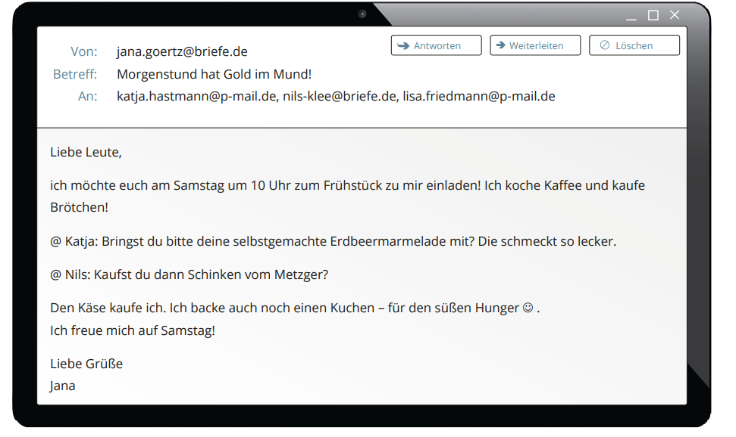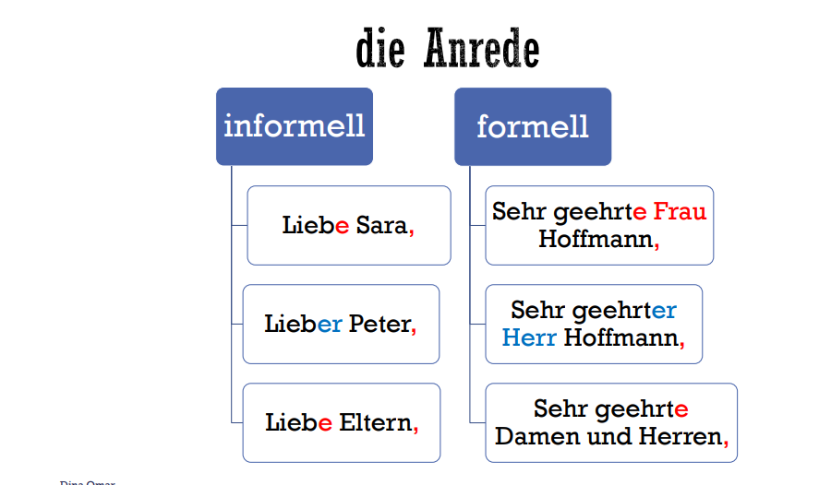

**der inhaltliche Teil → The content Part**

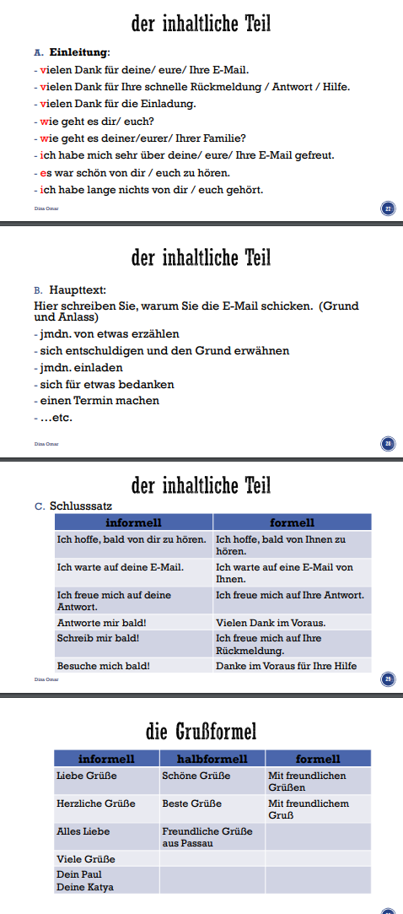

### **1. Der Inhaltliche Teil (The Content Section)**

#### **A. Einleitung (Introduction):**

**This is the opening of your email where you acknowledge or refer to the previous interaction. Here are examples:**

* **Danke sagen (Expressing thanks):**
  + **"Vielen Dank für deine/eure/Ihre E-Mail."  
    (Thank you for your email.)**
  + **"Vielen Dank für Ihre schnelle Rückmeldung/Antwort/Hilfe."  
    (Thank you for your quick reply/response/help.)**
* **Small talk (optional):**
  + **"Wie geht es dir/euch/Ihnen?"  
    (How are you?)**
  + **"Wie geht es deiner/eurer/Ihrer Familie?"  
    (How is your family?)**
* **Positive acknowledgment:**
  + **"Ich habe mich sehr über deine/eure/Ihre E-Mail gefreut."  
    (I was very happy about your email.)**
  + **"Es war schön, von dir/euch/Ihnen zu hören."  
    (It was nice to hear from you.)**
  + **"Ich habe lange nichts von dir/euch gehört."  
    (I haven’t heard from you in a long time.)**

#### **B. Haupttext (Main Text):**

**In this part, you explain the purpose of your email. It should include the main details or reason for writing. Some examples of what you can include:**

* **Tell someone about something:**
  + **"Ich möchte dir etwas erzählen."  
    (I want to tell you something.)**
* **Apologize:**
  + **"Ich möchte mich entschuldigen und den Grund erwähnen."  
    (I want to apologize and explain the reason.)**
* **Invite someone:**
  + **"Ich lade dich ein."  
    (I’m inviting you.)**
* **Express gratitude:**
  + **"Ich möchte mich für etwas bedanken."  
    (I want to thank you for something.)**
* **Arrange a meeting:**
  + **"Ich möchte einen Termin machen."  
    (I’d like to set up a meeting.)**

#### **C. Schlusssatz (Closing Sentence):**

**This is the last part of the email, where you end with a friendly or formal closing remark.**

* **Informell (Informal):**
  + **"Ich hoffe, bald von dir zu hören."  
    (I hope to hear from you soon.)**
  + **"Ich warte auf deine E-Mail."  
    (I’m waiting for your email.)**
  + **"Besuche mich bald!"  
    (Visit me soon!)**
* **Formell (Formal):**
  + **"Ich hoffe, bald von Ihnen zu hören."  
    (I hope to hear from you soon.)**
  + **"Ich freue mich auf Ihre Antwort."  
    (I look forward to your reply.)**
  + **"Vielen Dank im Voraus."  
    (Thank you in advance.)**

### **2. Die Grußformel (Closing Phrases)**

**The Grußformel is the closing phrase used at the end of an email, and it varies based on the formality of the email.**

* **Informell (Informal): Use this for friends, family, or close acquaintances.**
  + **"Liebe Grüße" (Kind regards)**
  + **"Alles Liebe" (All the best)**
  + **"Viele Grüße" (Best regards)**
* **Halbformell (Semi-formal): Use this for colleagues or people you know somewhat formally.**
  + **"Schöne Grüße" (Nice regards)**
  + **"Freundliche Grüße aus [Ort]" (Friendly greetings from [location])**
* **Formell (Formal): Use this for professional or official emails.**
  + **"Mit freundlichen Grüßen" (Yours sincerely)**
  + **"Mit freundlichem Gruß" (Kind regards)**

### **Summary for Writing Emails:**

1. **Start with an introduction (Einleitung): Mention thanks, small talk, or acknowledgment.**
2. **Main section (Haupttext): Provide details or explain the purpose.**
3. **Close (Schlusssatz): Use friendly or formal closing sentences.**
4. **End with a greeting (Grußformel): Choose based on the level of formality.**

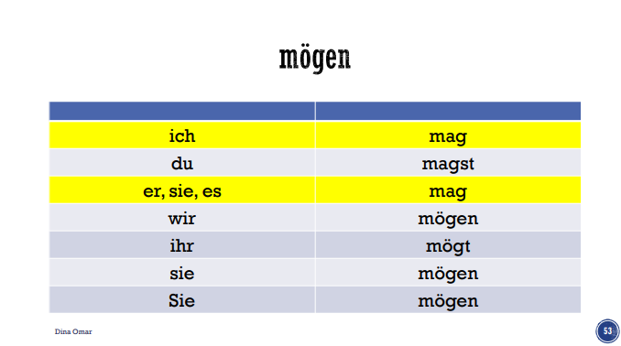

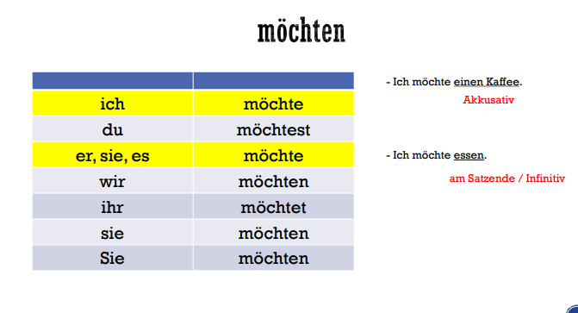

**The form “möchte” is actually the Konjunktiv II (subjunctive II) of the verb “mögen” (to like). However, in German, it is often used to express polite wishes or requests. Even though “möchte” is grammatically a subjunctive form, it functions like a normal modal verb in the present tense in sentences.**

### **Usage of “möchte” in Sentences:**

* **Meaning: To politely express a desire or to politely ask for something.**
* **Sentence Structure:**
  + **The modal verb “möchte” is placed in position 2 in the sentence.**
  + **The main verb is in the infinitive form and appears at the end of the sentence.**

### **Example in Practice:**

1. **Polite Wish:**
   * ***“Ich möchte jetzt nach Hause fahren.”*(I would like to go home now.)**
2. **Polite Request:**
   * ***“Ich möchte bitte ein Glas Wasser.”*(I would like a glass of water, please.)**
3. **Polite Intention:**
   * ***“Er möchte morgen ins Kino gehen.”*(He would like to go to the cinema tomorrow.)**
4. **Polite Question:**
   * ***“Möchtest du mitkommen?”*(Would you like to come along?)**

### **Key Takeaways:**

* **“möchte” is used in polite contexts instead of “will” (which can sound too direct or demanding).**
* **It behaves like other modal verbs:**
  + **Position 2 in the sentence for the modal verb.**
  + **The infinitive of the main verb is at the end of the sentence.**

